Max Shi  
E 234  
Professor De Rosa  
I pledge my honor that I have abided by the Stevens Honor System  
Homework 7  
Partner: Ashley McDermott



$$COP_{theoretical}=\frac{1}{1-\frac{Q_{L}}{Q_{H}}}=\frac{1}{1-\frac{273}{293}}=14.65 \\ W=75kW \\ COP_{actual}=\frac{200}{75}=2.667 \\ Because the actual COP is lower than the theoretical, this is possible.$$

$$η=0.55 \\ η=\frac{W_{net,out}}{Q_{in}} \\ 0.55=\frac{800}{Q_{in}}⇒Q_{in}=\frac{800}{0.55}=1454\frac{Btu}{min} \\ η=1-\frac{Q_{L}}{Q_{H}}⇒0.55=1-\frac{60+459.67}{T_{H}} \\ T_{H}=\frac{60+459.67}{1-0.55}=1154.82 R$$

|  |  |  |
| --- | --- | --- |
| Process | Delta S | Explanation |
| Adiabatic Irreversible | positive | Adiabatic -> Delta Q = 0  Irreversible -> S generated = positive $$\frac{ΔQ}{T}+S_{gen}=0+\left(+\right)=+$$ |
| Adiabatic reversible | zero | Adiabatic -> Delta Q = 0  Reversible -> s generated = 0 $$\frac{ΔQ}{T}+S_{gen}=0+\left(0\right)=0$$ |
| Reversible heat addition | Positive | Heat addition -> Delta Q = positive Reversible -> S generated = 0 $$\frac{ΔQ}{T}+S_{gen}=(+)+\left(0\right)=+$$ |
| Reversible heat rejection | negative | Heat rejection -> Delta Q = negative  Reversible -> S generated = 0 $$\frac{ΔQ}{T}+S_{gen}=(-)+0=-$$ |
| Irreversible heat rejection | Anything is possible | Heat rejection -> Delta Q = negative  Irreversible -> S generated = positive $$\frac{ΔQ}{T}+S_{gen}=\left(-\right)+\left(+\right)= ?$$ |
| Irreversible heat addition | positive | Heat addition -> Delta Q = positive  Irreversible -> S generated = positive $$\frac{ΔQ}{T}+S_{gen}=\left(+\right)+\left(+\right)= +$$ |

$$ΔS=\int_{1}^{2}{\frac{δQ}{T}}+S_{gen} \\ S_{gen}=0, \int_{1}^{2}{\frac{δQ}{T}}=\frac{ΔQ}{T}=\frac{900 kJ}{400+273.15} \\ ΔS_{fluid}=\frac{900}{400+273.15}=1.337\frac{kJ}{K} \\ ΔS_{source}=-{ΔS}_{fluid}(as T is the same)=-1.337\frac{kJ}{K} \\ ΔS_{total}=0$$

$$ΔS_{R-134a}=\frac{ΔQ}{T} \\ T=T_{sat@140kPa}=-18.77℃, ΔQ=180 kJ \\ ΔS_{R-134a}=\frac{ΔQ}{T}=\frac{180}{-18.77+273.15}=0.7076\frac{kJ}{K} \\ ΔS_{space}=\frac{ΔQ}{T} \\ ΔQ=-180 kJ, T=-10℃ \\ ΔS_{space}=\frac{-180}{-10+273.15}=-0.6840\frac{kJ}{K} \\ ΔS_{total}=ΔS_{R-134a}+ΔS_{space}=0.0236\frac{kJ}{K}$$

$$Δs=c_{p,avg}\ln{\frac{T_{2}}{T_{1}}}-R ln\frac{P_{2}}{P_{1}} \\ Δs=1.015\ln{\frac{465}{270}}-0.287\ln{\frac{350}{58}}=0.03589\frac{kJ}{kg*K}$$

4. $$S_{1}=1.0913*5=5.4565\frac{kJ}{K} \\ v_{1}=v_{2}=0.17172\frac{m^{3}}{kg} \\ @90 kPa, v_{f}=0.0007222, v_{g}=0.21261 \\ x=\frac{0.17172-0.0007222}{0.21261-0.0007222}=0.807 \\ S_{2}=m*s=5*\left(0.06003+0.807*0.89431\right)=3.9086\frac{kJ}{K} \\ S_{2}-S_{1}=3.9086-5.4565=-1.5478\frac{kJ}{K}$$ 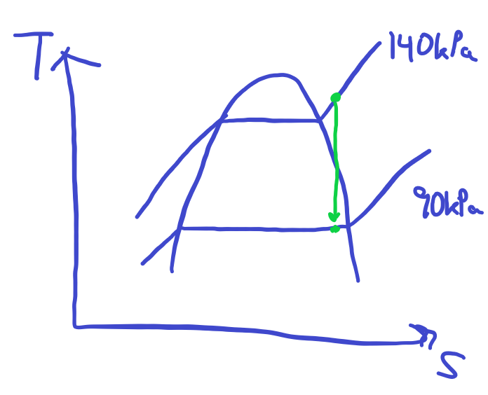
5. Although thermodynamics is not very applicable to my computer science major, I have seen concepts covered in thermodynamics briefly mentioned in some of my studies for my chemistry minor. The concept of entropy is especially applicable to chemistry, where the spontaneity of reactions is dictated by the Gibbs Free Energy equation, where ΔG = ΔH – TΔS. While the values in the equation itself are trivial, it illustrates the importance of change in entropy in creating favorable chemical reactions: because a negative ΔG value indicates a thermodynamically favored reaction, a more positive ΔS value indicates a more favorable reaction. This is in line with what we learned in thermodynamics, that real-world processes tend to generate entropy.   
     
   Another aspect that thermodynamics plays into chemistry is the concept of phase changes. We learned in chemistry that phase changes like evaporation or melting were endothermic, resulting in an increase in enthalpy, and freezing and condensation were exothermic, resulting in a decrease in enthalpy. In thermodynamics, I learned more about what those things actually mean, and how things like internal energy and enthalpy relate to terms such as endothermic and exothermic, which refer to changes in heat.